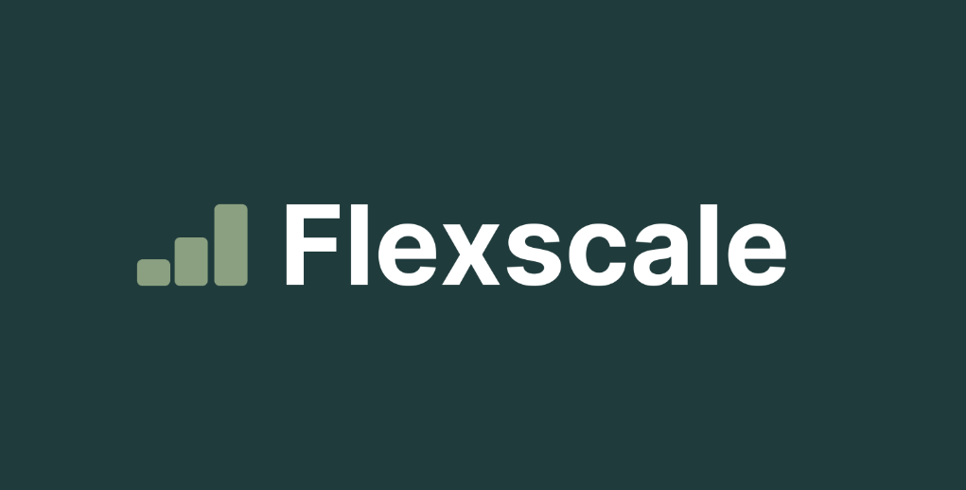

Flexscale LLC 10 Lynnfield, Irvine, CA,

92620, US

May 23rd, 2025

Verification Letter

To Whom it May Concern,

This letter certifies that Catherine Kate Stella Pleños provides services to Flexscale LLC from November 11th, 2024 and earns on a Time basis.

Feel free to contact us at [people@flexscale.com](mailto:people@flexscale.com) if you have any questions or concerns.

Contract Type

PAYG Contract

Payment Frequency

Semimonthly

Average Monthly Payments

$694.17

Contract Services

Customer Care Specialist - Data Rush Campaign

Regards,

*Julius Miranda Julius Miranda HR Manager*